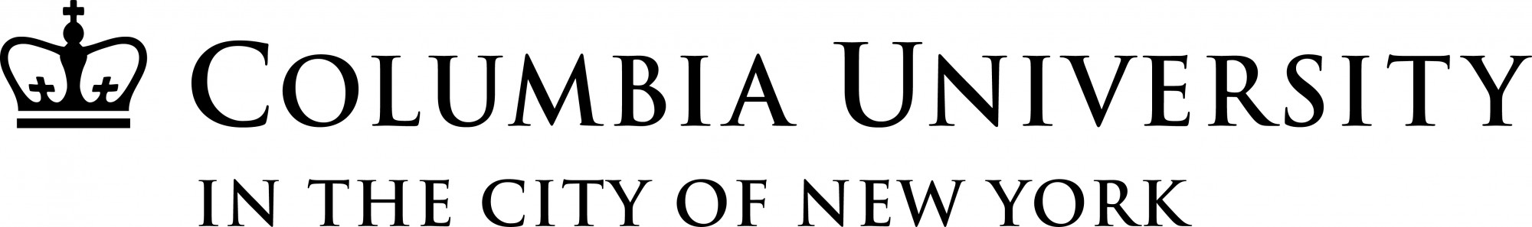
Department of History
Presents

A lecture by

Lynn M. Thomas
Professor of History, University of Washington

Tuesday, March 26th, 2019 | 6:00PM

East Gallery, Buell Hall
515 West 116th Street

TOPIC:

“Consumer Capitalism, Racialization,
and ‘Black is Beautiful’”

At the height of apartheid in South Africa, cosmetic skin lighteners were popular and highly profitable commodities. During the 1980s, opposition to skin lighteners became a corollary of the anti-apartheid movement. That anti-racist activism ensured that today South Africa possesses – on the books, at least – the world’s most extensive prohibitions on skin lighteners. This talk will examine how and why skin lighteners became such commonplace and contentious commodities in apartheid South Africa, and how that history was deeply connected to developments in the United States and East Africa.
Lynn M. Thomas is a Professor of History at the University of Washington, Seattle where she is also an adjunct faculty member in Anthropology and Gender, Women & Sexuality Studies. She is currently serving as the Interim Executive Director of the School of Drama. Thomas is the author of Politics of the Womb: Women, Reproduction, and the State in Kenya (2003), co-editor of The Modern Girl Around the World: Consumption, Modernity, and Globalization (2008) and Love in Africa (2009), and a former co-editor of the Journal of African History (2010-15). Her book Beneath the Surface: A Transnational History of Skin Lighteners is forthcoming with Duke University Press.

