CIVIL WAR AND RECONSTRUCTION AREA
at the
Popular Culture/American Culture Associations
National Conference 2023

San Antonio, Texas
APRIL 5-8, 2023
The Civil War and Reconstruction Area of the Popular Culture /American Culture Association is calling for papers on the American Civil War and Reconstruction for its national meeting, April 5-8, 2023 (Wednesday through Saturday), at the San Antonio Marriott Rivercenter in San Antonio, Texas. Papers are welcome from a range of disciplines, and may explore any topic or "reading" of the War and its impact on American Culture.
Past presentations have included such diverse subject areas as journals and letters, literature, photography, art, newspapers and journalistic history, counterfactual history, battle reenactments, music, Civil War politics (even events leading up to the war), battle narratives, soldiers’ memoirs, guerilla warfare, film, historiographical issues, women's narratives, women in combat, war games, secession politics, African-Americans at war, the Underground Railroad, Veterans’ organizations, modern pop culture, battlefield preservation, memorials, and material culture. Suggested special topics for this year could include German immigrants to Texas and their refusal to fight for the Confederacy (the Nueces Massacre, perhaps), the Secession of Texas, military politics, the Rhetoric of Secession, and Abolitionists and war.
Acceptance of your paper obligates you to appear and make an oral presentation. Sessions run for ninety minutes, and each presenter receives fifteen minutes to present, depending on the number of papers in each panel. Please plan to stay within this time limit. Graduate students are especially welcome to submit proposals. Whole panel proposals are also welcome.
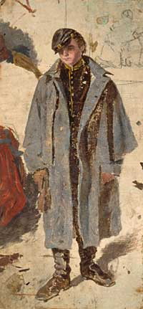
Please send an abstract of 100-250 words online at this URL: https://pcaaca.org/conference/2023 .
Deadline: Please submit proposals by Dec. 20, 2022
Area Co-Chairs

Dr. Michael Frawley
Department of History
The University of Texas of the Permian Basin
frawley_m@utpb.edu
ph. (432) 552-2314
Dr. Randal Allred
52 East 2075 South
Orem, UT 84058
randal.allred@byuh.edu
ph. (808) 277-0397

2023 Conference Dates and Deadlines
15 Aug-22 2023 Conference Information Available on Website
15 Sept-22 Submissions Open
07 Oct-22 Early Bird Registration Begins
20 Dec-22 Deadline for Paper Proposals
02 Jan-23 Early Bird Registration Ends
03 Jan-23 Regular Registration Begins
13 Jan-23 Preliminary Schedule Available
01 Feb-23 Regular Registration Ends for Presenters; Those Presenters Not Registered by this Date Will be Dropped; Late Registration Continues for Nonpresenters
17 Mar-23 Late Registration Ends for Nonpresenters
5-8 April-23 CONFERENCE IN SAN ANTONIO, TX

All presenters must be current, paid members of the PCA and registered for the conference. Non-presenters who attend the full conference must also pay membership fees.

To attend the National Conference, members must pay the membership fee and the registration fee. Membership fees are non-refundable and non-transferable.

